¿ 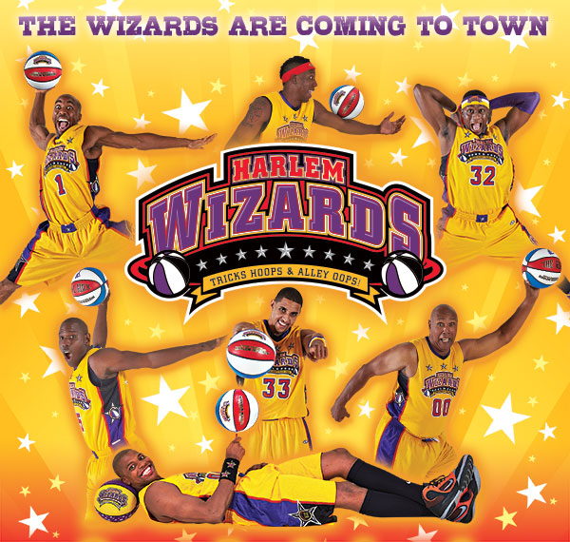
Don’t miss this fun-filled, high flying & interactive community event featuring the world famous Harlem Wizards basketball team as they take on the Delta Legends, a team of teachers and principals from all the Del Com Schools. Learn more about the Wizards now in their 55th season at www.harlemwizards.com. Come cheer on your favorite teachers!

Date & Time: Wednesday, February 7th, 7pm-9pm (Doors open @ 6pm)  VENUE: Delta High School  Fundraiser for: DelCom Foundation  Proudly Sponsored by: DelCom Foundation  Warm Up with the Wizards!  Buy and wear this year’s new Wizards jersey and and you can be a Wiz Kid! - The Fun begins soon after doors open. Our MC will introduce you as a Wiz Kid! - 30 mins. prior to show, you will be on the court warming up with the Wizards *First 75 purchased  We will be selling food, drinks and Wizards Souvenirs (cash or cc) to help raise money | GENERAL ADMISSION  Students: $ 7.00 advance $ 9.00 door  Adults: $ 9.00 advance $ 12.00 door  RESERVED  $ n/a Includes up close reserved seats and a free poster voucher  COURTSIDE PLUS  $ 25.00 Includes courtside reserved seating, an exclusive 10 minute meet & greet with 2-3 Wizards, free team poster and $10 discount on Wizards replica jerseys. VERY Limited (50 tickets). First come, first serve.  ORDER YOUR TICKETS NOW!  Visit http://www.harlemwizards.com and click “Buy Tickets”  or fill out ticket order form on reverse side  ***FREE AUTOGRAPH SESSION AFTER THE GAME!***  *This is not a drop off event, k-6 students must be accompanied by an adult
www.harlemwizards.com Buy tickets now! Wizard games sell out all over the country!

