TICKET ORDER FORM

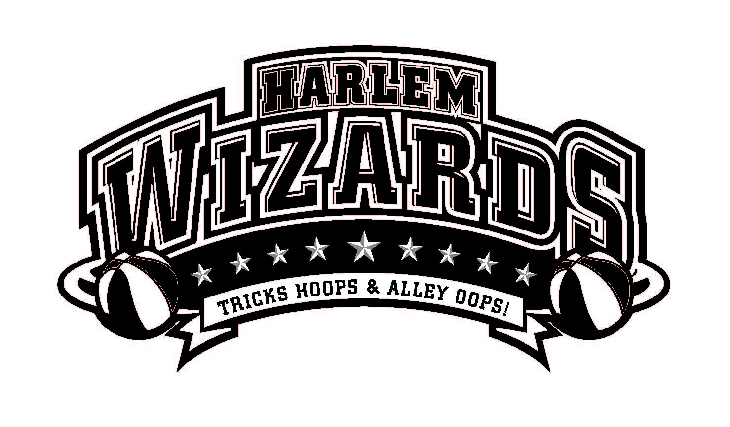
DELTA LEGENDS
Featuring: Teachers & staff from…
All Del Com Schools

VS

This Slamtastic Community Event Hosted and Proudly Sponsored By:
The DelCom Foundation

***ORDER YOUR TICKETS NOW! WIZARD GAMES SELL OUT ALL OVER THE COUNTRY!***

Date | Wednesday, February 7th |  | Ticket Type | Advance  Price | Door  Price | Quantity  Advance | Total
Time | 7pm (Doors open @6pm ) |  | Student | $ 7.00 | $9.00 |  | $
Venue | Delta High School |  | Adult | $ 9.00 | $12.00 |  | $
Fundraiser for: | DelCom Foundation |  | Reserved* | $ n/a | $ n/a |  | $
 |  |  | Courtside Plus** | $25.00 | $25.00 |  | $
 |  |  | Total |  |  |  | $

**Courtside seating (50 tickets available), 10 minute meet & greet with 2-3 Wizards, souvenir lanyard, free team photo, and $10 discount on Wizards replica jersey. Arrive at the gym 1 hour before game time

Special Opportunity to Warm up with the Wizards! (Maximum 75 kids)
Become a “Wiz Kid!”- With purchase of Wizards replica jersey you will be
able to join the players on the court for some pre-game fun! Experience includes:
- Personal introduction to crowd as a “Wiz Kid” member by our MC!
- Warm-up with the Wizards (beginning 30 minutes prior to game)!
- Participation in the Wizards grand entrance!
- Group photo opportunity with both teams

Order your jersey(s) now at www.harlemwizards.com* and pick up at the
Wizards Souvenir Store when you arrive!
*Go to Schedule & Tickets, search for your event date, and click the “blue select” button to purchase*
**In the event that your selected size does not fit or is unavailable, you may change sizes, or receive a full refund**

Total $ amount of Tickets: $__________

Student name____________________________ School_____________________________________ Teacher_______________________
Parent name___________________________ Phone #____________________________ Email_______________________________________

CASH (exact amount, please) AND CHECKS ARE ACCEPTED! – MAKE CHECKS PAYABLE TO: DelCom Foundation
Or buy your tickets online @ www.harlemwizards.com/schedule-tickets

*Children 3 & under admitted free *Non-Refundable
*Order does not guarantee purchase *We will notify you if tickets are sold out *
Please return this form to your school marked Harlem Wizards Tickets: c/o School Office. Make checks payable to: DelCom Foundation . Please note: Tickets ordered through the schools will be sent home with your child.
THIS IS NOT A DROP OFF EVENT – K-6 STUDENTS MUST BE ACCOMPANIED BY ADULT

